2. What is the difference between cat and more command?

-Cat print all the text of the file
more print as the screen

3. What is the difference between rm and rmdir using man?

-rmdir deletes the empty dirs
-rm deletes the files or the dirs with -r if dirs containing a files or sub dirs

4. Create the following hierarchy under your home directory:



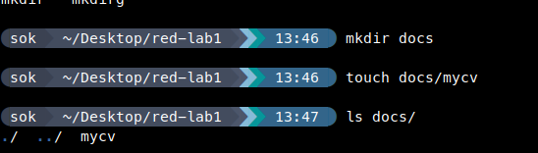

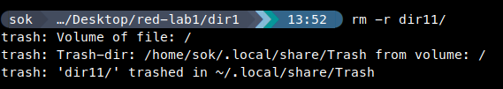
a
b rmdir -p deletes the parent dirs if its empty after deleting the subdirs
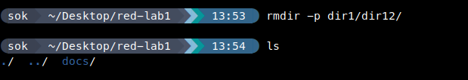

c

5-Copy the /etc/passwd file to your home directory making its name is mypasswd.
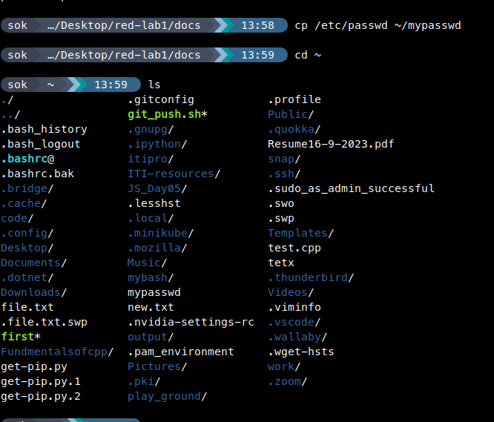

6-Rename this new file to be oldpasswd.

7-You are in /usr/bin, list four ways to go to your home directory
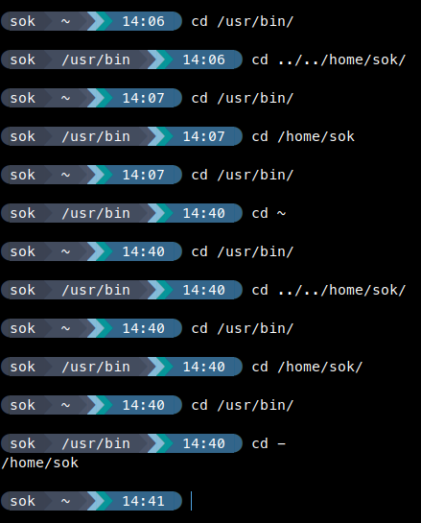

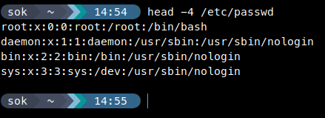
9-Display the first 4 lines of /etc/passwd

10-Display the last 7 lines of /etc/passwd

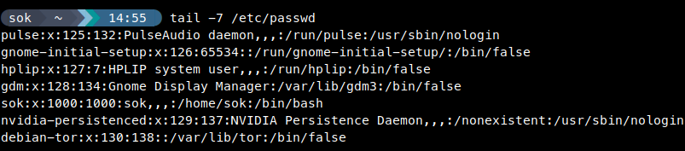
11-Display the man pages of passwd the command and the file sequentially in one command.

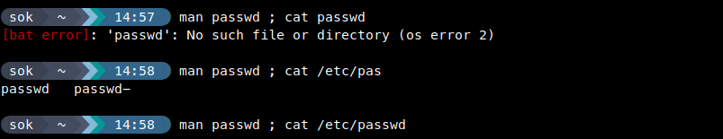
12-Display the man page of the passwd file.


13-Display a list of all the commands that contain the keyword passwd in their man page.

